Admission Policy
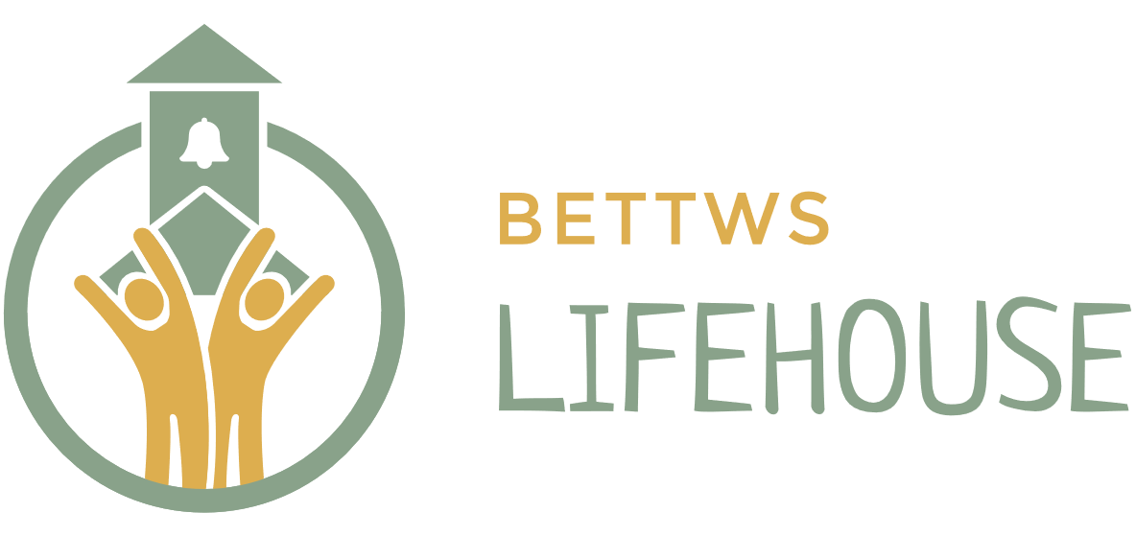

Date Written: May 2008
Last Reviewed: March 2019, March 2023,
March 2025
Next Reviewed: March 2027

Rationale

The Lifehouse exists because we have a fundamental belief that there is a sector of children whose needs cannot be met by mainstream education and for whom there is limited local provision. It is our aim to provide an education for children who need to have a more holistic approach and that takes account of their personal and social needs. We endeavour to work on nurturing self-esteem and allowing pupils to be themselves in a safe and encouraging environment.

Aims

To provide access to The Lifehouse:

- To provide an alternative for children who are not suited to mainstream education
- To provide a variety of experiences and tailor a curriculum to enhance personal strengths
- To nurture personal growth and encourage good citizenship
- To enable learning in academic and practical areas that can then be transferred into the workplace, wider society and future lives

To ensure that The Lifehouse is the most appropriate setting for pupils who have been referred.

To set selection criteria and procedures for admission that are consistent and fair.

To ensure that admission of a new pupil is the right decision for The Lifehouse community.

Criteria for admission

The Lifehouse accepts pupils who are aged between 7 and 14, up to maximum of 25 placements. Applications can be from parents or Education Authorities.

Admissions can be taken at any point in the academic year, which begins in September.

Consideration will be given to the current cohort’s ability to absorb a new admission. In a small setting such as The Lifehouse it is paramount that new admissions show the potential to become part of the team and accepted by their peers.

The Lifehouse acknowledges that mainstream education is the choice or option for the majority of children and the most appropriate place to gain a broad selection of qualifications. Therefore, The Lifehouse is suitable for children whose needs lie in other areas. This will include pupils whose academic achievement is disadvantaged by not having access to a more practical timetable, those who are struggling with self-esteem and finding their niche, those who are socially excluded and those at risk of exclusion, or who already have been excluded from mainstream school.

The Headteacher must agree that the pupil’s needs, learning difficulties or other special needs can be met by The Lifehouse.

Our pupils will be drawn from those that need

- An individual curriculum
- A safe and encouraging environment
- A variety of learning areas
- A high staffing ratio
- A small, consistent and calm setting in which to learn
- A strong emphasis on nurture and support to encourage self-development
- Practical learning opportunities

Where other agencies are involved, there will be agreement that a holistic environment is more beneficial than a purely academic route.

Pupils whose needs have included regular physical intervention or violence would rarely be considered as appropriate. Pupils who have a sibling already on roll, will not be considered until that sibling has left.

Any pupil referred to The Lifehouse will be considered by The Directors and Headteacher. The Headteachers will consult with the Lower School Management Team as to suitability of the placement.

The Directors and the Head teacher retain the right to refuse an application without giving reason. However, it would be normal procedure to give justification for that decision where ever possible. Factors which are not taken into account are skin colour, race, nationality or ethnic or national origin, religious faith, culture, area of residence or socio-economic group.

Record of Admissions

A register of admissions is kept in accordance with

The Education (Pupil Registration) (Wales) Regulations 2010
This can be found on Arbour (MIS system)

Date of amendments/Review | By whom
March 2019 | Fiona Davies
March 2023 | Fiona Davies
March 2025 | Fiona Davies

