Anti Bullying Policy
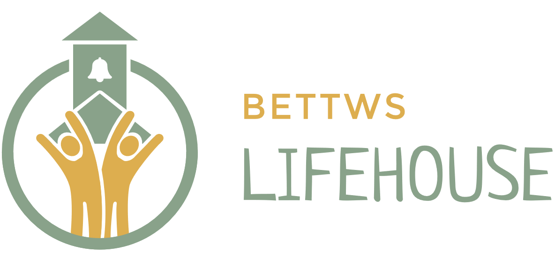

Date Written: May 2007
Last reviewed: April 2021, March 2023, June 2024, Jun 25
To be reviewed: June 2027

Rationale

This policy is drawn up with reference to and alongside:
Rights, Respect, Equality Guidance 2019
Estyn Review: Action on bullying June 2014
All Wales Practice Guides (Wales Safeguarding Procedures) 2019
Keeping Learners Safe – 283/2022
The Equality Act 2010

To be used and read in accordance with:
Bettws Lifehouse ‘Peer on peer abuse and relationship abuse’ policy and ‘online safety policy’

The Lifehouse is a school for children with emotional and behavioural difficulties, moderate learning difficulties and in many cases, students with ADHD, ASD and PDA. It is recognised that the students at the school will have significant impairments, including social and emotional challenges and those typical of students who are neurodiverse. This may influence the likelihood of events of bullying occurring and the procedures implemented to deal with bullying behaviour. The school, however, still needs to prepare for the event of bullying. Every student at the school should be able to learn in an environment free from bullying and where they feel safe and supported. This document has been created to ensure this happens.

Aim

In establishing guidance that applies local and national expectations to our practice we aim to offer pupils a structured, appropriate, accessible and varied experience when at school. This policy provides an overall framework for managing all types of bullying behaviour at our school.

The Lifehouse, like society, has standards and expectations of behaviour that include mutual respect for all members of the community. It is understood that everyone must feel valued and safe in their environment if they are to flourish. Individuality is celebrated and members are encouraged to accept others in a non-judgemental way. Bullying comes in many guises and will not be tolerated on any level.

- Best practice occurs where positive leadership promotes a strong ethos of respect for all members of the school community, including respect for difference and diversity.
- Staff at The Lifehouse are trained and deployed to ensure best practice occurs:
  - staff ensure by rigorous and consistent supervision and guidance that opportunities for bullying and other types of oppressive behaviours are kept to a minimum;
  - all teaching and non-teaching staff share the responsibility of ensuring that The Lifehouse is a safe place;
  - school staff all uphold high professional standards and consistently model positive school appropriate relationships.
  - school staff regularly consult pupils about bullying and other issues through the mentoring system in place;
  - school council discuss and support pupils to openly raise issues around bullying, however trivial
  - pupils feel confident that their views and concerns are listened to by the adults around them and will be dealt with effectively.
  - Pupils have frequent opportunity to discuss and raise issues of concern with a trusted adult within school
  - Parents and carers have open and consistent lines of communication into school to raise any concerns thy may have

This policy will ensure that:
- all staff, parents and students, when possible, should have an understanding of what bullying is.
- all staff should know what the school policy is on bullying and follow it when bullying is reported.
- all parents and students, when possible, should know what the school policy is on bullying, and what they should do if the event arises.
- as a school we take bullying seriously. Students and parents should be assured that they will be supported when bullying is reported.
- All reported bullying behaviour will be addressed, and targeted work put in to address the core problem.

Definition of bullying

Bullying is behaviour by an individual or group, repeated over time, that intentionally hurts another individual or group either physically or emotionally. Bullying can take many forms (for instance, cyber-bullying via text messages or the internet), and is often motivated by prejudice against particular groups, for example on grounds of race, religion, gender, sexual orientation, or because a child has some variation in care. It might be motivated by actual differences between children, or perceived differences. Stopping violence and ensuring immediate physical safety is obviously a school’s first priority but emotional bullying can be equally as damaging as a physical assault. Each case will be considered on an individual basis.

Many experts say that bullying involves an imbalance of power between the perpetrator and the victim. This could involve perpetrators of bullying having control over the relationship which makes it difficult for those they bully to defend themselves. The imbalance of power can manifest itself in several ways; it may be physical, psychological (knowing what upsets someone), derive from an intellectual imbalance, or by having access to the support of a group, or the capacity to socially isolate. It can result in the intimidation of a person or persons through the threat of violence or by isolating them either physically or online.

Definitions of bullying vary, but there are three essential elements that are always present:

- an unequal power relationship between the bully and target
- the deliberate and continued use of aggression
- the causing of physical pain and/or emotional distress

It is important to recognise that bullying is not an isolated incident, but a series of repeated attacks.

The Lifehouse also recognises that bullies often emerge through their own lack of confidence or insecurities and this will be addressed with those found to be perpetrators.

Online safety

The rapid development of, and widespread access to, technology has provided a new medium for ‘virtual’ bullying, which can occur in or outside school. Cyber-bullying is a different form of bullying and can happen at all times of the day, with a potentially bigger audience, and more accessories as people forward on content at a click.

Our ‘online safety policy’ outlines the protective measures we employ at The Lifehouse and what a pupil should do if they are victim of online bullying.

Systems

The Lifehouse operates a community-teaching ethos and as such, each member is responsible for ensuring that incidents of bullying behaviour are reported and dealt with. Staff will monitor discussion time and moderate ideas if they are felt to be inappropriate. Explanation will be given if it is felt the view comes from a point of ignorance rather than maliciousness. All free time is highly supervised, with staff interacting with pupils throughout play times to help pupils manage boundaries and social rules.

Awareness of bullying

Staff should constantly be vigilant for:
- Physical intimidation
- Verbal animosity
- Prejudicial comments
- Judgemental comments
- Put-downs
- Abusive language
- Ostracising from the group
- Intimidating body language
- ‘Banter’
Other signs may be:
- be unwilling to go to school: feigning illness, increase in absences, late arrival at school or lessons
- decline in quality of work
- come home with possessions missing or damaged
- become withdrawn and anxious/change in their usual behaviour
- have nightmares
- ask for or steals money
- refuse to say what is wrong
- give improbable excuses for any of the above situations
- be anxious about checking computer messages, e-mails or texts
- self harm
- consider or attempt suicide

Any form of behaviour that causes distress for another member of the school community is an issue that needs to be dealt with. Some forms of intimidation can be quite subtle and be aimed a particular area of weakness, personality trait or a belief which others may be unaware of.

Raising Awareness

- Open and frank discussion about any incidence that has taken place
- Clear definition of the sanctions that took place as a result of this
- Constant affirmation that everyone is valued and encouraged, irrespective of ethnicity, nationality, colour or sexual orientation
- Each person should be encouraged to be their own voice and to use their champion and specific allocated time with their champion to work on strategies to empower themselves
- Discussion around areas where individuals have experienced bullying in other areas of their life
- ‘Student Awareness’ workshops on bullying if and when appropriate.
- Specific work in the PSHE curriculum

The Lifehouse staff are aware that because it is a small community, the choice of adults to disclose to is limited. Therefore relationships between pupils, and staff and pupils will be constantly monitored at staff meetings. Each pupil has a staff ‘champion’ with whom a close working relationship is established.
If we are aware of bullying that is taking to place to a pupil outside of the Lifehouse community we will endeavour to get support for the pupil from an appropriate person. We will clearly define if an instance is, in fact, abuse. If so, this is covered in our Safeguarding and Child Protection policy.

Procedures

Students at The Lifehouse often lack social and communication skills which can sometimes lead to “challenging behaviour”. The school aims to ensure that all pupils learn in a supportive, caring and safe environment, without fear of being bullied. Our Golden words which are promoted throughout the school are: Safe, Respect, Learn. The overall position of the school is that bullying will not be tolerated and always acted on.

The following steps may be taken when dealing with incidents:

- If bullying is suspected or reported, the incident will be dealt with immediately by the member of staff who has been approached.
- The bullying will be discussed with the children involved using amongst other opportunities, their mentoring sessions
- Children will be listened to sympathetically and impartially. The member of staff will not make any premature judgments.
- Those concerned will be encouraged to resolve the situation amicably.
- All parties will be led to consider other people’s perceptions and feelings and explore the factors which contributed to the situation.
- All parties will consider alternative strategies, and how they might change their behaviour.
- A clear account of the incident will be recorded in learning diaries and picked up as a personal target to improve if appropriate.
- A member of Senior Management will interview all concerned and will record the incident when it is deemed serious.
- Parents will be kept informed through Champion reports via email or phone calls.
- Appropriate sanctions will be implemented, and a way forward outlined in consultation with all parties concerned.
- The situation will be reviewed after a period of time to ensure that resolution has been securely achieved.

Pupils who have been bullied will be supported by:
- reassuring the pupil and ensuring close monitoring and supervision
- offering continuous support and personal mentoring
- restoring self-esteem and confidence through careful curriculum and timetable planning

Pupils who have bullied will be helped by:
- establishing the function of the behaviour in order to put in place appropriate consequences
- Identifying positive personal targets in the PCP
- Using mentoring and potentially therapeutic work to teach new ways to express themselves
- informing parents or guardians to ensure the consistency between home and school to promote generalisation of approach

.
Possible consequences could include:
- time-out from teaching in the main hall with others
- joining a therapeutic session in curriculum or free time
- missing a group session
- completing chores around school
- missing out on positive whole school time
- extreme continuing and persistent behaviours may result in short exclusions or more long-term timetable changes

The school ensures that with the use of any of the above techniques there is always the opportunity to teach alternative more appropriate behaviours and skills to the student. Within the curriculum the school will raise the awareness of the nature of bullying as appropriate, in an attempt to eradicate such behaviour.

All pupils and staff at The Lifehouse work in a close, nurture group environment. Instances of bullying are dealt with promptly and efficiently and the ethos of tolerance and acceptance is very much part of day to day expectation.

Useful links:

CEOP (Child Exploitation and Online Protection Centre)
www.ceop.police.uk

Anti-bullying alliance http://www.anti-bullyingalliance.org.uk/

Kidscape www.kidscape.org.uk

Restorative justice in schools www.restorativejustice.org.uk/restorativepractice-schools

Diana award http://diana-award.org.uk/

LGBT advice http://www.schools-out.org.uk/

Keeping Learners Safe - 2022

